**PICNIC GAMES**

**Developer Guide**

|  |  |  |
| --- | --- | --- |
| **Faculty** | **Miss Neelam Malik** | |
| **Batch** | **2209B1** | |
| **Group** | **B** | |
| **Serial No.** | **Enrollment Number** | **Student Name** |
| 1. | Student1418143 | MUHAMMAD ALEEM |
| 2. | Student1407103 | MUHAMMAD UMAIR |
| 3. | Student1416155 | HARIB UDDIN |
| 4. | Student1424703 | ABDULLAH SHAZAD |

**TABLE OF CONTENT:**

Documentation ---------------------------------------------------------------- 1

Acknowledgement ------------------------------------------------------------ 3

Certification -------------------------------------------------------------------- 4

Problem Statement ------------------------------------------------------------- 5

Screen Shots --------------------------------------------------------------------- 7

Task Sheet Review 2 --------------------------------------------------------- 14

Task Sheet Review 3 ----------------------------------------------------------15

**ACKNOWLEDGEMENT**

We are thankful to Almighty, ALLAH that by His grace we have been successful. we presenting on Dream Weaver in your hands. We have tried our best to take all relevant important topics in consideration so that this project may become comprehensive.

This is our First Year Semester E-project. We have tried our best & struggled for a better outlook to come. This project has been developed in Dream Weaver. We choose to make Webpage for Picnic Games.com as a project. We find easy to do coding in Dream Weaver.

We earnestly hope that this project will provide all the necessarily information required for the user to fulfill their inspiration. However, suggestions for improvement of the project will be thankful received & acknowledge.

**THANKING YOU……**

**CERTIFICATION:**

This is to certify that,  
MUHAMMAD ALEEM, MUHAMMAD UMAIR, HARIB UDDIN, ABDULLAH SHAHZAD

Have successfully designed, develop and submitted the Games website.

**Problem Statement**

In today’s busy and active world, quality time with family, friends and relatives is

often overlooked, but picnics can be helpful in making up for some of this lost time.

Spending time together benefits children by providing security, love, and a sense of

belonging. Taking time to talk with your children is a great way to connect with them

and learn from each other. Regular communication can also give family members

chances to plan other fun and engaging activities.

Fun games and little competitions are great ways to keep children occupied while

engaging with the family.

Hence it is thought of developing a website which will provide variety of

indoor/outdoor picnic games that can be enjoyed with all.

**Requirement Specification:**

The Web site is to be created based on the following requirements.

1) The Home Page should be created making use of Sections with a suitable

logo, the header section can be added which will show images of various

creative products.

2) The site must contain the links to navigate through any category for the

information.

3) The games should be categorized according to the type of games

indoor/outdoor

4) Also there should different be sections for

- Kids

- Males

- Females

- Family games

5) When a user selects any particular category, a list of available game options

for that particular category will be displayed

6) All details about the selected game to be displayed as material needed, time

required, how to play etc with the demo videos / instruction document ,also

these should be stored in Individual Word documents which can be

downloaded or viewed by the User who wishes to see the same.

7) Along with the games there should also be a section for a common iternery

for small getaways with suggested locations.

8) Site Makers Contact us page: contact us details with location should be

displayed using GeoLocation API (eg. GoogleMaps).

9) Navigation should be smooth and images should be clear.

**Hardware/ Software Requirements**

**Hardware**

* A minimum computer system that will help you access all the tools in the courses is a Pentium 166 or better
* 64 Megabytes of RAM or better

**Software**

* Notepad/HTML editor
* Dreamweaver
* IE 5.0/ Netscape 6.0

**Screenshots**

**Home page**

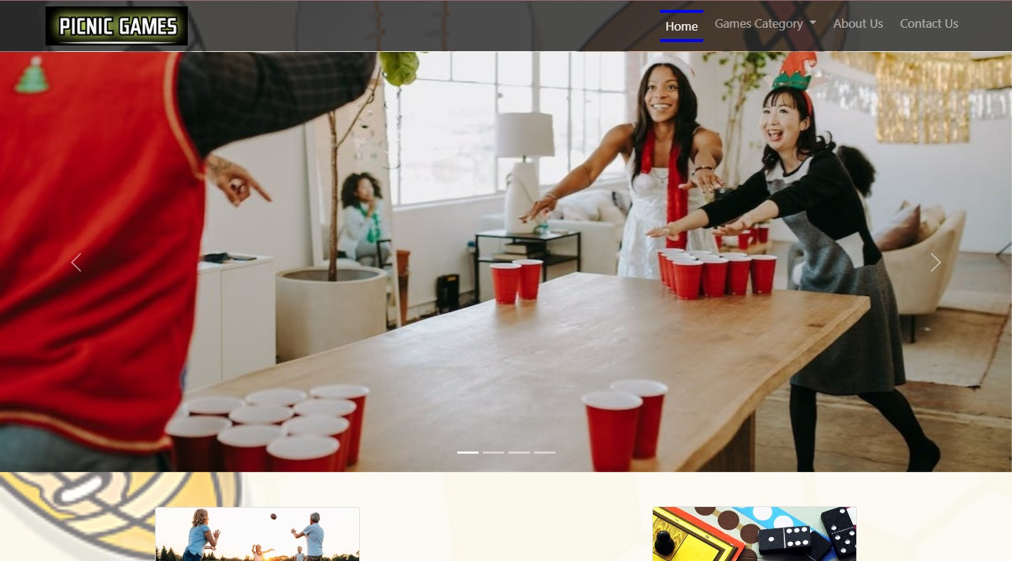

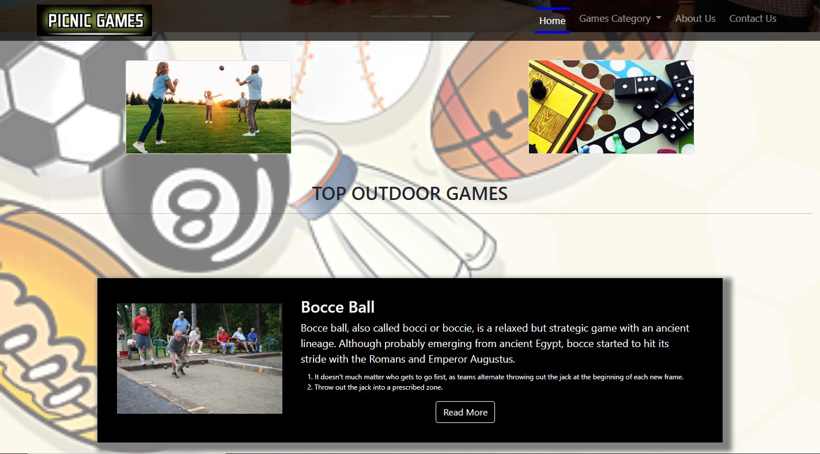

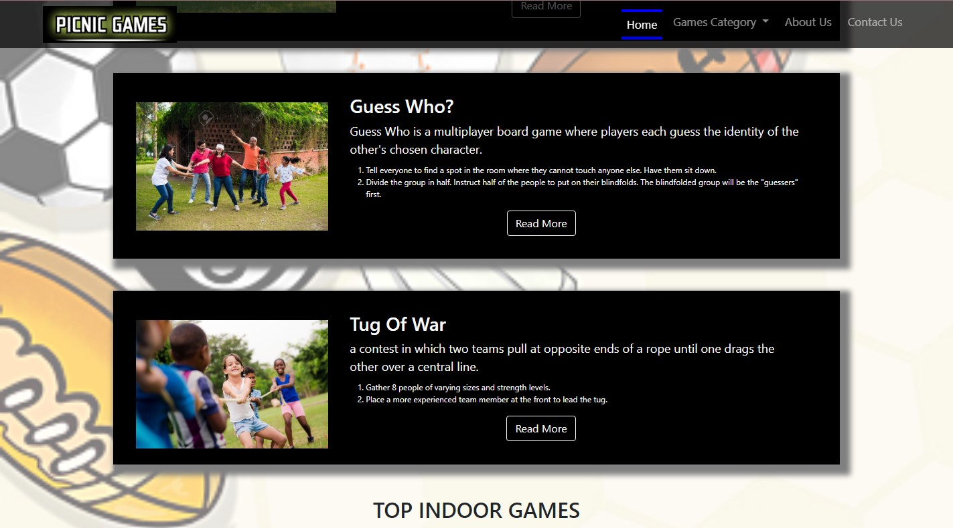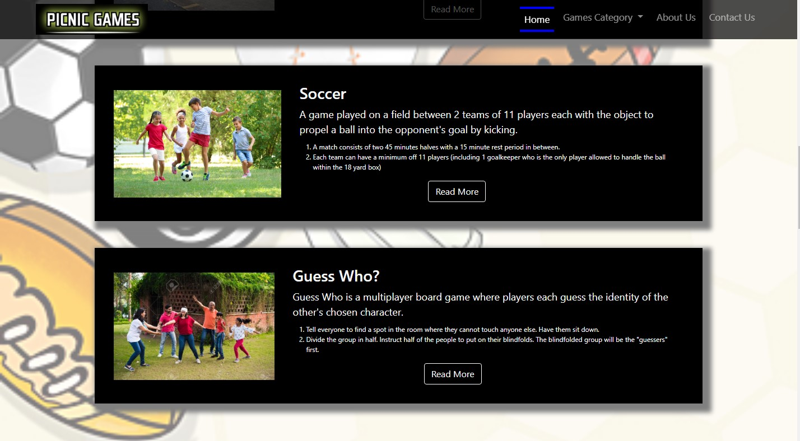

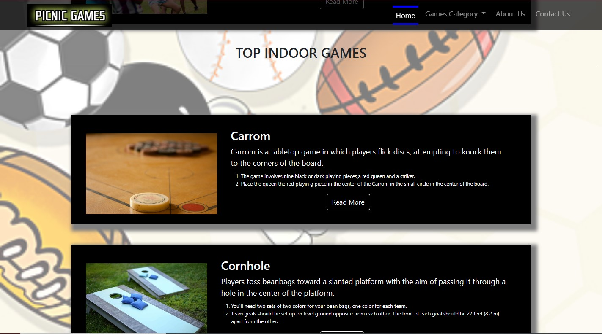

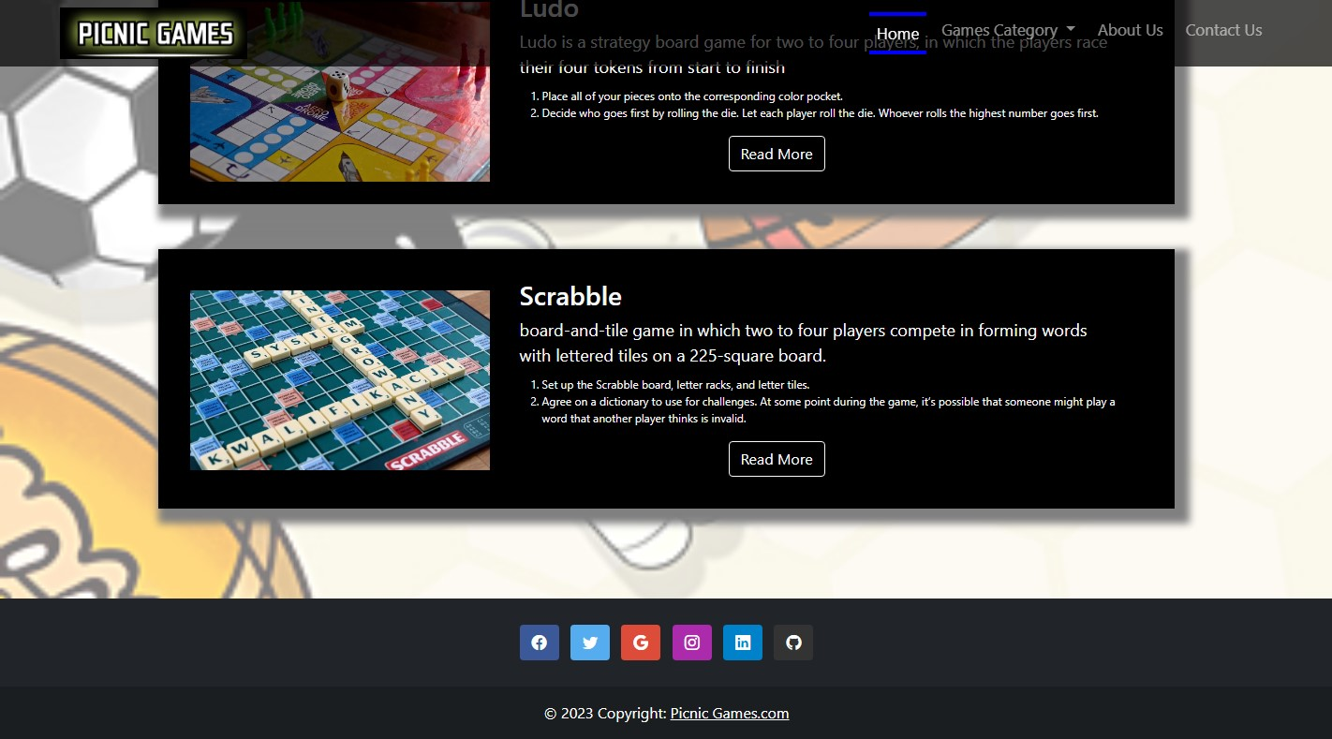

**Instruction Page**

1. **Indoor**
2. **Outdoor**

**Indoor Games**

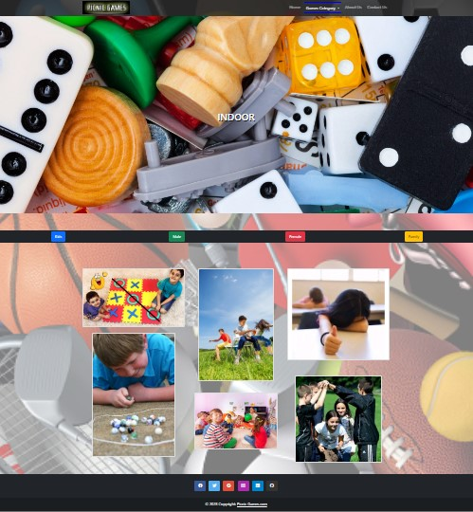

**Outdoor Games**

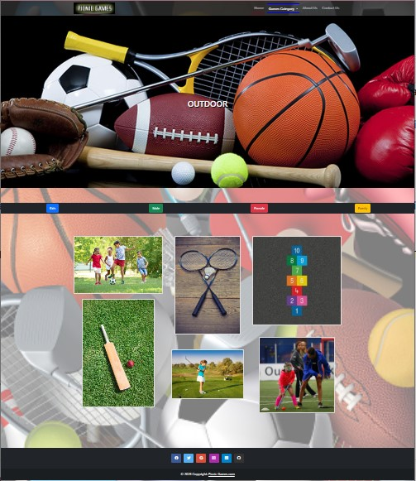

**Map**

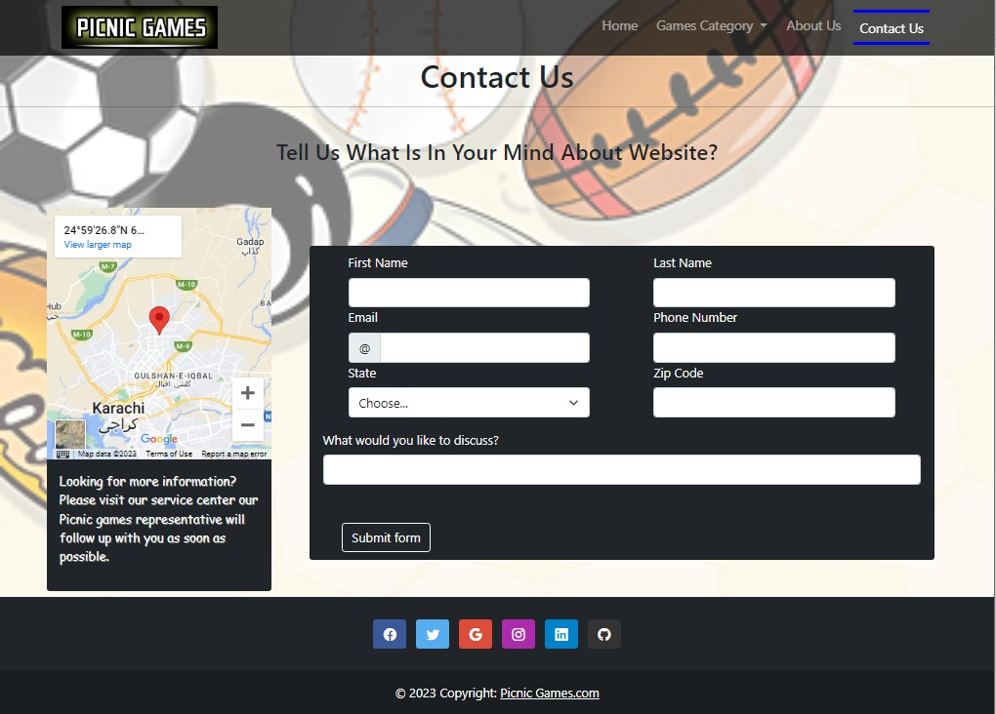

**TASK SHEET REVIEW 2**

|  |  |  |  |  |  |  |
| --- | --- | --- | --- | --- | --- | --- |
| Project Ref. No.: eP/Advertisement Portal Management System/01 | | Project  title | Date of Preparation of Activity Plan | | | |
| No | Task | Picnic Games | Actual | Actual | Team-mate | Status |
| Start Date | Days | Names |
| 1 | Navbar | 9/JAN/2023 | 1 | ABDULLAH SHAHZAD | Complete |
| 2 | Main Body Navbar | 10/JAN/2023 | 2 | ABDULLAH SHAHZAD | Complete |
| 3 | Footer | 12/JAN/2023 | 1 | ABDULLAH SHAHZAD | Complete |
| 4 | Home | 16/JAN/2023 | 4 | MUHAMMAD ALEEM | Complete |
| 5 | Instruction Page | 20/JAN/2023 | 4 | MUHAMMAD ALEEM | Complete |
| 6 | Indoor Games | 24/JAN/2023 | 4 | MUHAMMAD ALEEM | Complete |
| 7 | Outdoor Games | 28/JAN/2023 | 4 | RAGHIB RIZWAN RABANI | Complete |

**TASK SHEET REVIEW 3**

|  |  |  |  |  |  |  |
| --- | --- | --- | --- | --- | --- | --- |
| Project Ref. No.: eP/Advertisement Portal Management System/01 | | Project title | Date of Preparation of Activity Plan | | | |
| No | Task | Picnic Games | Actual  Start Date | Actual  Days | Team-mate  Names | Status |
| 1 | Kids | 30/JAN/2023 | 3 | MUHAMMAD UMAIR | Complete |
| 2 | Family | 2/FEB/2023 | 3 | MUHAMMAD UMAIR | Complete |
| 3 | Male | 5/FEB/23 | 3 | HARIB UDDIN | Complete |
| 4 | Female | 6/FEB/23 | 3 | ABDULLAH SHAHZAD | Complete |
| 5 | J query and JavaScript |  | 7/FEB/23 | 2 | MUHAMMAD ALEEM | Complete |